Alpha-Beta Pruning
AIM:
To write a Python program to implement the Alpha-Beta Pruning algorithm to optimize the Minimax search.
ALGORITHMS:
- Start.
- Construct the game tree.
- Initialize alpha to negative infinity and beta to positive infinity.
- Evaluate the game tree using the Minimax algorithm.
- At a MAX node, choose the maximum child value and update alpha.
- At a MIN node, choose the minimum child value and update beta.
- If alpha is greater than or equal to beta, prune the remaining unexplored branches of that node.
- Continue evaluating the remaining branches that are not pruned.
- Determine the optimal move using the final Minimax value.
- Stop.

CODE:
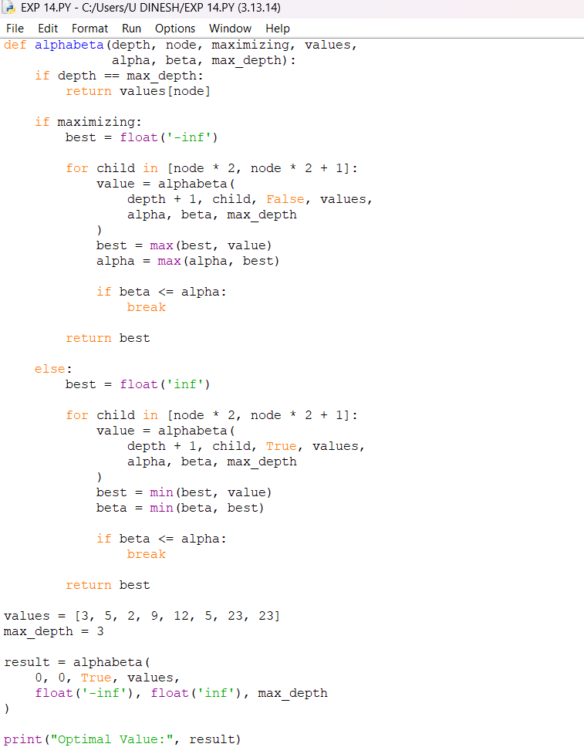

OUTPUT:
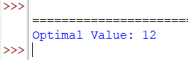

RESULT:

Alpha-Beta Pruning Algorithm: Unnecessary branches are pruned to improve the efficiency of the Minimax algorithm.

